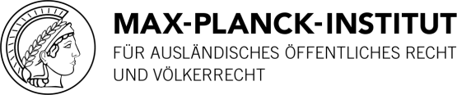
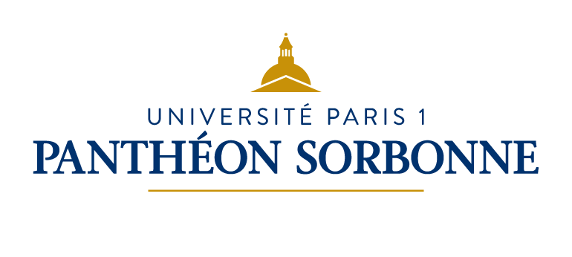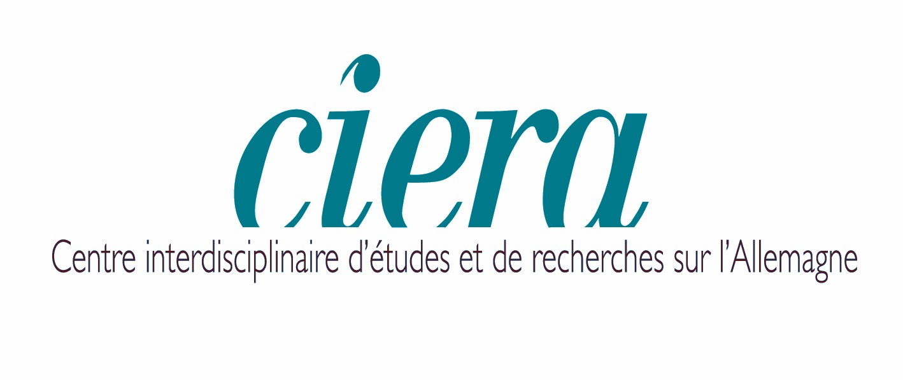
Digital surveillance and cyber spying: French and German perspectives
Maison de la recherche
28 rue Serpente 75006 Paris
22nd and 23rd September 2016

The colloquium dedicated to the topics of digital surveillance and cyberespionage from a “Franco-German perspective” will take place on the 22nd and 23rd of September, 2016 in Paris. This colloquium is organised within the framework of the HeiParisMax partnership (between Sciences Po, Paris 1 Pantheon-Sorbonne University, Heidelberg University and the Max Planck Institute for Comparative Public Law and International Law), and, together with the CIERA as well as the Collège franco-allemand en droit public compare européen. Should you be interested in attending this colloquium, please write a short message to the following email address: cyberdf@gmail.com. Please note that given the state of emergency enacted in France, it is required that any person attending a public event must be pre-registered on a list before the event takes place. Therefore, please send us an email by 21st September 2016 at the latest, if you wish to attend.
This event is aimed at young researchers and practitioners, including those with a legal background, or working on digital surveillance and cyber espionage. Issues about digital surveillance and cyber espionage are not new, and have already been discussed extensively in literature, especially in recent years with respect to the fight against terrorism. Yet, this is a rapid-evolving and dynamic field. Snowden’s leaks and the recent terrorist attacks in Paris and Brussels (among other recent terrorist attacks in Europe), have given the subject added urgency and opened up dramatic new lines of inquiry. Thus, this colloquium will articulate some of the legal issues arising from this context by proposing the following axes.
French and German legal frameworks applicable to intelligence agencies and law-enforcement authorities in light of international and European law
The first axis will focus on the opportunity to investigate the various legal elements originating from German, French, European and International Law applicable to digital surveillance practices. A special focus will be given to the conditions surrounding the authorization of digital surveillance practices from a two-fold perspective: one internal to States and the European legal order, and one external to them.
Control of digital surveillance activities and cyber espionage in Germany and in France
With respect to this second topic, the various concrete modes of control of these activities in Germany and in France could be discussed, whether already existing or envisaged, taking into account: the political and parliamentarian modes of control, the administrative and constitutional mechanisms for oversight, as well as judicial control. National, territorial and temporal criteria that exert an influence on these modes of control could also be treated.
The Franco-German and European cooperation in matters of intelligence and law-enforcement activities
A last point will be made one the existing European cooperation, in particular the role played by the “Franco-German couple”, in intelligence and law-enforcement matters. Indeed, the digital sector is an important part of the Franco-German cooperation. It includes the development of a cooperative project for storing and processing data collected in Europe (“the European cloud” or “European Internet”); data protection, via the creation of a database and a monitoring system targeting potential terrorists; and regulation of illegal content on the Internet, such as the glorification of terrorism or incitement of hatred and violence against a community.

